CS231n学习笔记

Assignment Git:

<https://github.com/CS231n-zju/CS231n>

视频地址：

[https://www.youtube.com/playlist?list=PL3FW7Lu3i5JvHM8ljYj-zLfQRF3EO8sYv\](https://www.youtube.com/playlist?list=PL3FW7Lu3i5JvHM8ljYj-zLfQRF3EO8sYv/)

课程作业：

<http://cs231n.github.io/>

Syllabus:

<http://cs231n.stanford.edu/syllabus.html>

Note翻译:

<http://www.52ml.net/17723.html>

**Week5**

Understanding and Visualizing Convolutional Neural Networks 1

Transfer Learning and Fine-tuning Convolutional Neural Networks 2

Assignment3_Q1: Image Captioning with Vanilla RNNs 2

1.参考材料 2

2. RNN BP传播的原理 2

3.Word embedding(Forward和BP) 3

4.sigmoid和softmax的区别 3

5. rnn训练过程 3

6.rnn预测过程 4

Assignment3_Q2: Image Captioning with LSTMs 5

1.step forward 5

2.lstm_backward(dh, cache) 5

3.Extra Credit: Train a good captioning model! 6

3.1一种机器翻译的评价准则——Bleu 6

3.2用前面的numpy版本实现 6

3.3用tensorflow实现(多层LSTM) 6

Assignment3_Q3: Network Visualization: Saliency maps, Class Visualization, and Fooling Images 6

1.一些问题记录 6

2.Saliency Maps 7

3.Fooling Images 7

# Understanding and Visualizing Convolutional Neural Networks

激活函数层可视化时可以发现的问题:

some activation maps may be all zero for many different inputs, which can indicate dead filters, and can be a symptom of high learning rates.

权重层可视化时可以发现的问题:

越平滑训练效果越好.

Noisy patterns can be an indicator of a network that hasn’t been trained for long enough, or possibly a very low regularization strength that may have led to overfitting.

输出AlexNet第一层:

发现灰度特征和彩色特征明显有聚类现象,主要是因为AlexNet有两个流去处理他们.

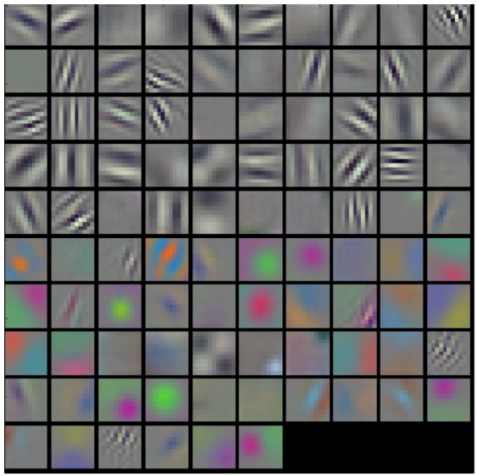

The color/grayscale features are clustered because the AlexNet contains two separate streams of processing, and an apparent consequence of this architecture is that one stream develops high-frequency grayscale features and the other low-frequency color features.

介绍把图像从高维空间映射到低维空间,但依旧保留图像像素点两两之间的距离的方法:t-sne,同时,经过t-sne之后,语义相近的图像会挨得比较近.

如何知道,识别图像中的狗的时候,我们得到的结果是来自于这只狗还是背景中的一些可能存在与狗的语义相关的信息,方法就是滑窗遮挡图像中的一部分,看概率会不会变化.

# Transfer Learning and Fine-tuning Convolutional Neural Networks

# Assignment3_Q1: Image Captioning with Vanilla RNNs

## 1.参考材料

<http://cs224d.stanford.edu/>

## RNN BP传播的原理

dprev_h=np.zeros((N,H))

for ti in range(T-1,-1,-1):

dx[:,ti,:], dprev_h, dWx_tmp, dWh_tmp, db_tmp=rnn_step_backward(

dh[:,ti,:]+dprev_h, cache[ti])

dWx+=dWx_tmp

dWh+=dWh_tmp

db+=db_tmp

dh0=dprev_h

## 3.Word embedding(Forward和BP)

- x: Integer array of shape (N, T) giving indices of words. Each element idx

of x muxt be in the range 0 <= idx < V.

- W: Weight matrix of shape (V, D) giving word vectors for all words.

- out: Array of shape (N, T, D) giving word vectors for all input words.

前向:

out=W[x[:,]]

cache=(x,W)

后向:

np.add.at(dW,x[:],dout[:])

numpy.add.at用法:

<https://docs.scipy.org/doc/numpy/reference/generated/numpy.ufunc.at.html#numpy.ufunc.at>

## 4.sigmoid和softmax的区别

都在[0,1]之间

Sigmoid:2018-01-14 11-26-08屏幕截图

Softmax: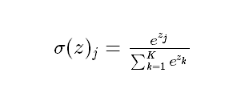

总结：

(1)sigmoid将一个real value映射到（0,1）的区间（当然也可以是（-1,1）），这样可以用来做二分类。

(2)softmax把一个k维的real value向量（a1,a2,a3,a4….）映射成一个（b1,b2,b3,b4….）其中bi是一个0-1的常数，然后可以根据bi的大小来进行多分类的任务，如取权重最大的一维。

## rnn训练过程

At training time, we have access to the ground-truth caption, so we feed ground-truth words as input to the RNN at each timestep.

在训练过程中,每次输入GT和上一时刻的输出,学习的是上下文关系,因此每次的输入就有GT,希望预测出的序列和目标序列接近(用loss衡量)

这里captions是GT

captions_in = captions[:, :-1]

captions_out = captions[:, 1:]

In the forward pass you will need to do the following:

(1) Use an affine transformation to compute the initial hidden state

from the image features. This should produce an array of shape (N, H)

(2) Use a word embedding layer to transform the words in captions_in

from indices to vectors, giving an array of shape (N, T, W).

(3) Use either a vanilla RNN or LSTM (depending on self.cell_type) to

process the sequence of input word vectors and produce hidden state

vectors for all timesteps, producing an array of shape (N, T, H).

(4) Use a (temporal) affine transformation to compute scores over the

vocabulary at every timestep using the hidden states, giving an

array of shape (N, T, V).

(5) Use (temporal) softmax to compute loss using captions_out, ignoring

the points where the output word is <NULL> using the mask above.

①首层的输入hidden其实是图片特征*W_proj+b_proj

h0=np.dot(features,W_proj)+b_proj

②把前N-1个GT做word embedding

③做前向rnn,生成的是(N, T, H)的word串,即预测值

④计算score(N, T, V)和loss

注意temporal_softmax_loss()里mask的作用,mask跳过所有对计算loss没有贡献的字符,比如<NULL>这样的标记

※注意到这里需要学习的几个参数:

①W_proj和b_proj:用来把图片转成第一层隐含层

②W_embed(vocab_size单词个数, wordvec_dim每个单词向量的长度):把单词转成向量的矩阵

③Wx,Wh,b:注意到权值共享,处理当前单词,上一层,以及偏置

④W_vocab(hidden_dim, vocab_size),b_vocab:计算score的矩阵

## 6.rnn预测过程

我们会使用rnn_step_forward而不是rnn_forward

①对前一个单词用训练好的embedding矩阵做embedding,其中第一个是<start>

②用①中处理好的词向量和前一个状态,去预测下一个状态,其中第一个h0是图像

③用②中的结果,用我们学好的W_vocab和b_vocab去得到现在整个词库里所有单词的得分,取最高的作为我们预测的这个时刻的单词

You will need to initialize the hidden state of the RNN by applying the learned affine transform to the input image features. The first word that you feed to

the RNN should be the <START> token; its value is stored in the variable self._start. At each timestep you will need to do to:

(1) Embed the previous word using the learned word embeddings

(2) Make an RNN step using the previous hidden state and the embedded

current word to get the next hidden state.

(3) Apply the learned affine transformation to the next hidden state to

get scores for all words in the vocabulary

(4) Select the word with the highest score as the next word, writing it

to the appropriate slot in the captions variable

For simplicity, you do not need to stop generating after an <END> token

is sampled, but you can if you want to.

HINT: You will not be able to use the rnn_forward or lstm_forward

functions; you'll need to call rnn_step_forward or lstm_step_forward in

a loop.

# Assignment3_Q2: Image Captioning with LSTMs

## 1.step forward

- x: Input data, of shape (N, D)

- prev_h: Previous hidden state, of shape (N, H)

- prev_c: previous cell state, of shape (N, H)

- Wx: Input-to-hidden weights, of shape (D, 4H)

- Wh: Hidden-to-hidden weights, of shape (H, 4H)

- b: Biases, of shape (4H,)

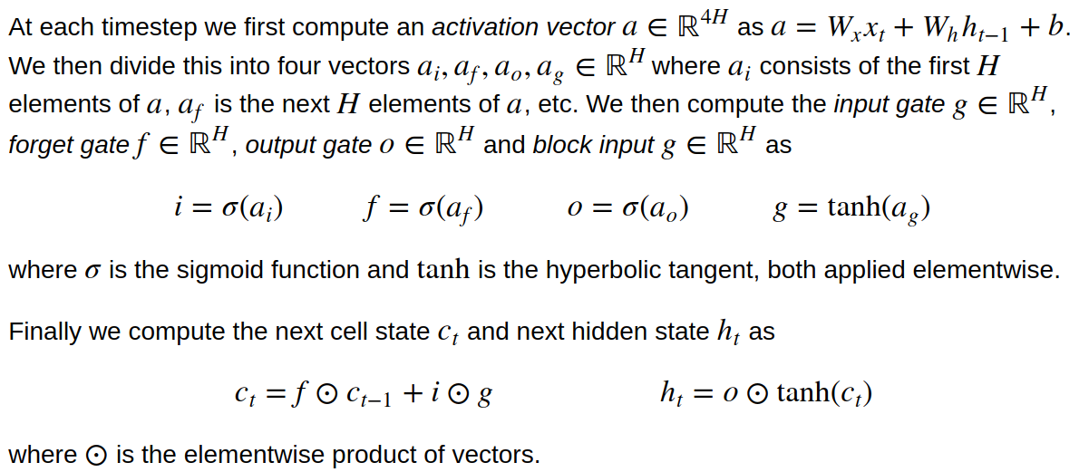

①a=np.dot(x,Wx)+np.dot(prev_h,Wh)+b

②这时把a分成4份,ai,af,ao,ag

③分别用sigmoid和tanh激励函数得到:i,f,o,g

④2018-01-14 19-05-24屏幕截图

计算2个量:next_h, next_c

## 2.lstm_backward(dh, cache)

为什么初始化:

dnext_c=np.zeros((N,H))

for ti in range(T-1,-1,-1):

dx[:,ti,:], dprev_h, dprev_c, dWx_tmp, dWh_tmp, db_tmp=

lstm_step_backward(dh[:,ti,:]+dprev_h, dnext_c, cache[ti])

dnext_c= dprev_c

dWx+=dWx_tmp

dWh+=dWh_tmp

db+=db_tmp

## 3.Extra Credit: Train a good captioning model!

### 3.1一种机器翻译的评价准则——Bleu

### 3.2用前面的numpy版本实现

### 3.3用tensorflow实现(多层LSTM)

需要做几件事:

①定义跑模型并且阶段性输出结果的函数:

def run_model(session, predict, loss_val, Xd, yd,

epochs=1, batch_size=64, print_every=100,

training=None, plot_losses=False):

②多层lstm的实现

③可以注意一下rnn里怎么做dropout

# Assignment3_Q3: Network Visualization: Saliency maps, Class Visualization, and Fooling Images

GAN的预备操作:

In this notebook we will explore the use of image gradients for generating new images.

这一次,用整个CNN去定义一个loss,用bp去求解dx!然后合成图片去最小化这个loss.

这个part会探索三个问题:

* Saliency Maps(显著图): Saliency maps are a quick way to tell which part of the image influenced the classification decision made by the network.
* Fooling Images: We can perturb an input image so that it appears the same to humans, but will be misclassified by the pretrained network.一些生成的图片,会被分类器误分类.
* Class Visualization: We can synthesize an image to maximize the classification score of a particular class; this can give us some sense of what the network is looking for when it classifies images of that class. 生成一个图片去最大化某一类图的分类score,这会give us some sense of网络分类时所关注的关键点.

## 1.一些问题记录

(1)Squeezenet.ckpt找不到

解决方法:

<https://www.reddit.com/r/cs231n/comments/6fhz3z/assignment_3_squeezenet/?st=jcfq1gkp&sh=55497490>

|  |
| --- |
| cp squeezenet.ckpt.data-00000-of-00001 squeezenet.ckpt |

直接把squeezenet.ckpt.data-00000-of-00001复制一个squeezenet.ckpt

Tensorflow的模型的三个文件:

* model.ckpt.meta
* model.ckpt.index
* model.ckpt.data-00000-of-00001

其中:

Meta保存图结构,data保存里面所有的变量的具体值

具体解释:

①meta file: describes the saved graph structure, includes GraphDef, SaverDef, and so on; then apply tf.train.import_meta_graph('/tmp/model.ckpt.meta'), will restore Saver and Graph.

使用protocol buffer来保存整个tensorflow graph.例如所有的variables, operations, collections等等。这个文件使用.meta后缀

Checkpoint二进制文件2个,二进制文件包含所有的weights,biases,gradients和其他variables的值:

②index file: it is a string-string immutable table(tensorflow::table::Table). Each key is a name of a tensor and its value is a serialized BundleEntryProto. Each BundleEntryProto describes the metadata of a tensor: which of the "data" files contains the content of a tensor, the offset into that file, checksum, some auxiliary data, etc.

③data file: it is TensorBundle collection, save the values of all variables.

## 2.Saliency Maps

计算图片对分类结果的gradient : 图片产生一点点修改的时候,classification的结果会变化多少.

先求loss对于图像的梯度,再求绝对值,再求3个通道上的最大值.

we take the absolute value of this gradient, then take the maximum value over the 3 input channels

## 3.Fooling Images

沿着某一类的score的gradient上升的方向创造一张图片

直到:分类器认为这个图就是这一类

这张图长得会非常非常像猫,但是却会利用分类器的梯度漏洞,被分类成某一个特定的类别target_y,比如狗,比如船

代码:

|  |
| --- |
| iters_num=50    g=tf.gradients(model.classifier[0,target_y],model.image)  dX = learning_rate * g / tf.norm(g)  for ti in range(iters_num):  feed_dict= {model.image:X_fooling}  np_dx=sess.run(dX,feed_dict)[0]  X_fooling+=np_dx |

## 4.Class visualization

优化问题:

2018-01-15 22-39-38屏幕截图

Graph设置:

|  |
| --- |
| loss = model.classifier[0,target_y]-0.5*l2_reg*(model.image*model.image)  grad = tf.gradients(loss,model.image)[0]  dX=learning_rate*grad/tf.norm(grad) |

# Assignment3_Q4: Style Transfer